Accounting Procedures Purpose The purpose of documenting accounting procedures is to:

1. Ensure the proper recording of financial transactions.

2. Make sure that there is consistency of accounting and financial reporting.

3. Provide documented evidence that there are proper reporting, and financial internal controls.

4. Act as guidance for accounting personnel recording cash receipts and disbursements.

2

Cash Disbursements

In an exempt organization-operating as a charter school-cash disbursements are generally the most numerous financial transactions that occur during a monthly time period.

Cash disbursements are usually made in the form of a check drawn on the operating account.

The normal starting point for a cash disbursement, is the receipt of an invoice from a vendor.

The danger of the lack of control over managing cash disbursements is: over-payment, duplicate payment, or payment of fraudulent invoices.

3

Recording Invoices

► In the QuickBooks Online accounting program, invoices are referred to as “Bills”; the vernacular term in general used by the public at large (i.e., “I need to pay my bills”).

► Each individual Bill received by LATCA is an individual transaction; that should be accounted for as a stand alone entry into the accounting system.

► Although Bills are individually recorded as a single financial transaction, several “Bills” may be paid by the issuance of a single check.

► The important Bill information components recorded into the system are:

A. Vendor name

B. Bill date

4

Recording Invoices

C. Bill number

These elements of recording the Bill are critically important. The QuickBooks Online system files transactions by: Vendor name, Bill date, and Bill number.

This information is recorded by QuickBooks in the vendors’ transaction file. The Bill number is key to locating a transaction in the system, and the date is used to present the transaction amount on the proper financial statement date.

Additionally, during the financial audit process, the auditor selects a sample of checks issued during the year, and matches the check number to the invoices paid by that specific check. The invoice numbers listed on the check stub must match the invoices recorded in the system, and in the vendors’ files. 5

Recording Invoices

► Step by Step instructions for recording invoice are:

1. Click on the “+New” oval (see page 7) on left side of the QuickBooks home page. 2. In the “New” list the second column from the left is “Vendor”.

3. The 3rd selection under Vendors is “Bill” (see page 8). To open the Bill input page click on “Bill”. 4. Enter the vendors name in the box marked “Vendor” (see page 9).

5. Enter the Bill date in the box marked “Bill Date”

6. Enter the Bill number in the box marked “Bill no.”

7. Select an account number from the “Category” drop down menu.

8. Enter the amount of the Bill in the box marked “Amount”.

► The above listed “8 steps” will complete the process for recording invoices. Page 9 shows steps 4 thru 7 on the QuickBooks Bill.

6

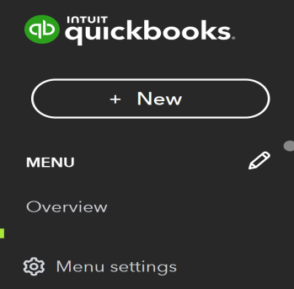7

Paying Bills

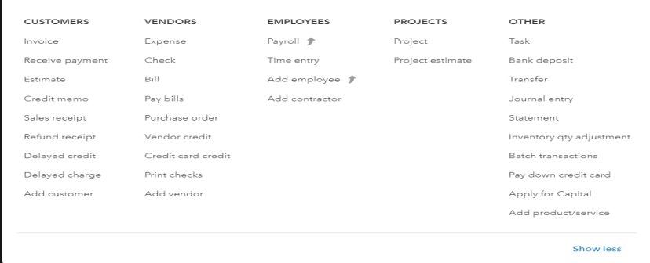8

Paying Bills-Recording Invoices 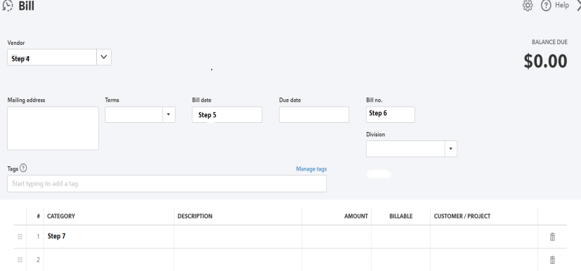9

Paying Bills-Recording Invoices

► Performing steps 4 through 7 will ensure that information required for invoices to post to the accounting system.

► Additionally, for transaction review purposes, it is helpful if a brief comment is enter into the description box (e.g., classroom supplies, student activity, etc.)

10

Paying Bills-Creating Checks

► After invoices are entered into the system, creating checks to pay them will complete the accounts payable process.

► To pay bills perform steps as follows:

► Click on the “+New” oval on the left side of the Ouickbooks home page. ► Under “Vendors” click on the 4th item “Pay Bills”.

► All unpaid invoices in the system are listed on the “Pay Bills” page (see page 12).

► To select an invoice for check preparation click on the box next to each invoice approved for payment.

11

Paying Bills

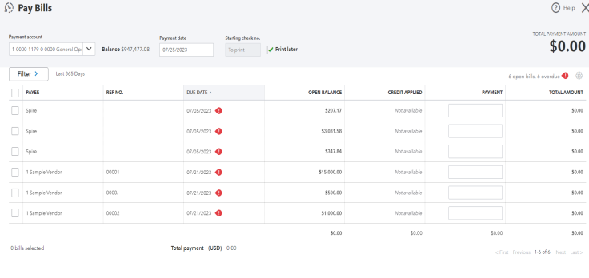12

Paying Bills-Check Preparation

► After Bills have been selected for payment, it is time to create checks.

► In the lower right hand corner of the “Pay Bills” screen, there is a green oval with the caption “Save and Print” Click it.

► The program will advance to the “Print Checks” screen (see page 14).

► At the top left, there is a box with the bank account information; ensure that the correct account is being used for printing checks.

► There is a starting check number box. Prior, to printing review the blank checks to ensure that the starting check number is correct.

► Click on the boxes next to each check, and in the lower right hand current click on review and print.

13

Paying Bills-Check Preparation

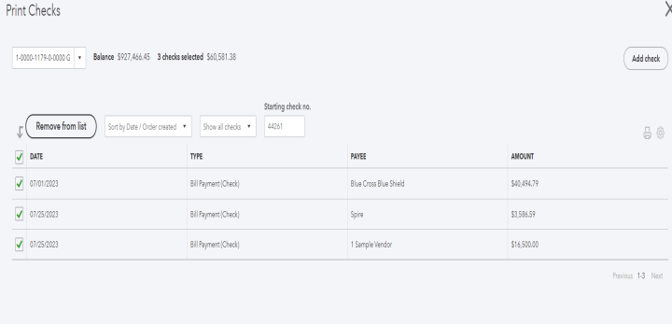14

Cash Receipts

► Basically, revenues flowing into an organization are generally received in one of three ways. They are receipt of actual currency, checks, or automated clearing house (ACH) transactions.

► As previously noted in the accounts payable section, safe guarding of assets is critical for survival of an organization.

► Conversely, failure to properly account for cash receipts provides an opportunity for loss; due to lost or misplaced donor checks, lost deposits, ACH fraud, or theft.

► It is essential that timely, legible accounting records are maintained.

► Part of the internal control procedures related cash, is that deposits must be created and entered into the accounting system. 15

Cash Receipts-Bank Deposits

► To facilitate effective control over cash receipts, recommended procedures are as follows:

► Currency received should be counted, observed and documented in the presence of at least two staff members.

► Upon completion of the count, the dollar amount should be communicated in writing to the accounting staff member.

► The accounting/business department will enter the deposit into the accounting system, and an electronic deposit slip will be created and matched with the cash deposit.

16

Cash Receipts-Bank Deposit

► The procedures to record cash received, and create a bank deposit are as follows:

► To record a contribution, grant or other amounts received to a specific donor or grantor create a sales receipt (see page 20) as follows:

1. Click on the “+New” oval in the upper left on the Quickbooks home page. 2. In the first column under customers select “Sales receipt”.

3. Enter the donor/grantor name in the customer box. If the customer is already in the system, after a few letters the name will appear in the box. If the name is not in the system, a “+Add new” will appear; in this case click on add new, and a new customer box will appear. Fill in the new customer information.

17

Cash Receipts-Bank Deposit

4. Complete a sales receipt for each check received from donors or grantors. Also, complete a sales receipt for any significant cash received from a specific donor.

5. For the “Deposit to” box, select “Undeposited Funds” from the drop down menu.

6. To create the deposit slip, click on “+New” oval on Quickbooks homepage.

7. On the right under the “Other” column heading “Bank deposit” is the first item listed: Click on it, the bank deposit screen will appear.

8. All undeposited sales receipts enter into the system will appear on the bank deposit screen.

9. To include a sales receipt in the deposit, click on the box next to the sales receipt.

18

Cash Receipts-Bank Deposit

10. On the lower half of the deposit slip is “Add funds to this deposit” section.

11. This section of the deposit slip is for cash or miscellaneous receipts that do not require recording to a specific individual, donor, or grantor.

12. In the accounting system the only support for this type of deposits is the deposit slip, and the deposit will not appear in the donor’s file.

19

Bank Deposit-Sales Receipt

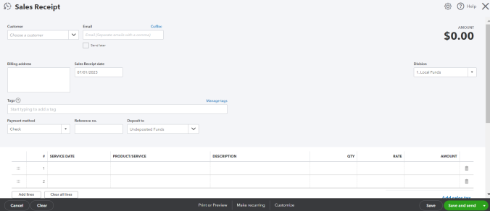20

Bank Deposits-Deposit Slip

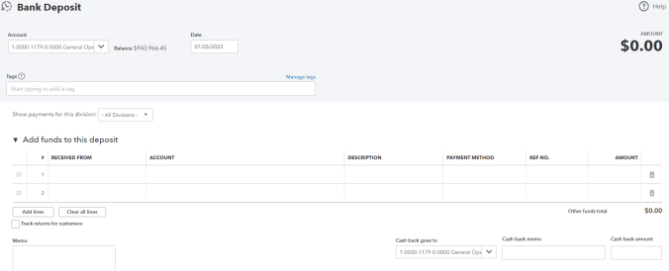21

Summary

Regardless of type, accounting is the life blood of all organizations and business entities. Internal controls maintains the integrity of the accounting system, and as a result all reports derived from the system.

Systems and procedures are not static. They must be reviewed, modified and updated as rules, laws and the organization’s environment changes.

The procedures outlined in this document are based upon an assessment of the current conditions, staffing, and reporting requirements of Lee A. Tolbert Community Academy.

22LATCA

Accounts Payable

and

Cash Receipts Processing Edward Wallace, CPA